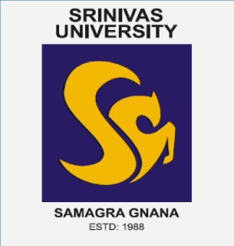
SRINIVAS UNIVERSITY
(PRIVATE UNIVERSITY ESTABLISHED UNDER KARNATAKA STATE ACT NO. 42 OF 2013)
Institute of Computer & Information Sciences
A Mini-Project report on`
“HOTEL MANAGEMENT SYSTEM”
Submitted in partial fulfillment of the requirement
for the II Semester in the degree
BACHELOR OF COMPUTER APPLICATIONS
by
Student Name Registration No
1. NIDHI J SHETTY 03SU23BC008
2. SUHAS N KUMAR 03SU23BC014
3. Y FEROZA 03SU23BC016

Under the guidance of
N. L. MURTHY
Assistant Professor, Project Guide
Institute of Computer & Information Sciences
SRINIVAS UNIVERSITY

SRINIVAS UNIVERSITY
Institute of Computer & Information Sciences
2023-24
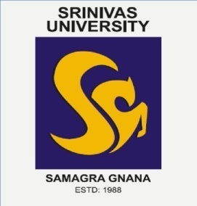
CERTIFICATE
This is to certify that the project entitled
“HOTEL MANAGEMENT SYSTEM”
Submitted in partial fulfillment of the requirement of
BACHELOR OF COMPUTER APPLICATIONS
Submitted by
Student Name Registration No
1. NIDHI J SHETTY 03SU23BC008
2. SUHAS N KUMAR 03SU23BC014
3. Y FEROZA 03SU23BC016

During the academic year 2023-24

Internal Guide Head of the Institution
N. L. MURTHY Dr. S. K. PRASAD
Assistant Professor Dean of the Institution
Srinivas University Srinivas University

ACKNOWLEDGEMENT

It gives us great pleasure to acknowledge with thanks, our respectful and beloved ones for helping us in bringing out this project report successfully.
First and foremost, we thank the Management of Srinivas University for providing resources and platform to develop this project.
Next, we would like to thank with immense gratitude to our Dr. S.K. Prasad, Dean, Srinivas University, Bangalore for encouraging us to undertake this project.
We express our gratitude to N. L. Murthy, Assistant Professor, Institute of Computers & Information Sciences, Srinivas University for his constant support in completion of the project.
Finally, we thank our parents and our friends for helping and encouraging us during the period of our project.

Place : Bangalore

Date :

Student Name Registration No.
1. NIDHI J SHETTY 03SU23BC008
2. SUHAS N KUMAR 03SU23BC014
3. Y FEROZA 03SU23BC016

DECLARATION

We, the students of II semester BCA at Srinivas University, hereby declare that, this project entitled “Hotel Management System” is an independent and original work carried out by us and under the guidance of Mr. N. L. Murthy, Assistant Professor, Srinivas University, submitted to university in the partial fulfilment of requirement for the award of the Degree of BCA during the AY 2023-24.
We, also declare that this report is Bonafede work carried out by us and has not been submitted to any other University/Institution in the partial fulfilment of any other Diploma or Degree.

Place : Bangalore

Date :

Student Name Registration No.
1. NIDHI J SHETTY 03SU23BC008
2. SUHAS N KUMAR 03SU23BC014
3. Y FEROZA 03SU23BC016

REPORT INDEX

SL NO. | CONTENTS | PAGE NO.
 | ABSTRACT
1. | INTRODUCTION | 1-2
 | 1.1 PROJECT INTRODUCTION | 1
 | 1.2 AIM & OBJECTIVES | 2
2. | MODULES OF THE PROJECT | 3-4
3. | HARDWARE & SOFTWARE REQUIREMENTS | 5
 | 3.1 HARDWARE REQUIREMENTS | 5
 | 3.2 SOFTWARE REQUIREMENTS | 5
4. | ABOUT THE SOFTWARE TOOLS USED | 6-9
 | 4.1 C++ PROGRAMMING | 6
 | 4.2 C GRAPHICS & FILE HANDLING | 7
5. | SOURCE CODE & SCREEN SHOTS | 10-45
6. | CONCLUSION & FUTURE ENHANCEMENT | 46-47
 | BIBLIOGRAPHY | 48

ABSTRACT

The Hotel Management System (HMS) is a sophisticated software solution aimed at transforming the way hotels operate and deliver exceptional guest experiences. This report outlines the system’s various components, functionalities, and the benefits it offers to both hotel management and guests.
The HMS serves as a centralized platform that effectively integrates and automates several crucial functions, enhancing efficiency, service quality, and revenue generation in the hospitality industry.
It streamlines the processes related to reservations, room inventory management, billing, staff management, billing, staff management, and reporting the system offers a holistic approach to hotel operations. This report provides an In-Depth exploration of each aspect of the HMS and its potential impact on the Hotel Industry.

